1. Comparison Table: PPC vs Organic Search for 'best headphones'
When you search 'best headphones' on Google, you see two types of results.
Basis of Difference | PPC (Pay Per Click) Ads | Organic Search Results
1. Position & Label | Appear at the top and bottom of the page with Sponsored / Ad label. Example: Sponsored - Sony WH-1000XM5 - Buy Now at Croma or Boat Headphones Official Site | Appear in the middle of the page without any label. Example: The 10 Best Headphones of 2025 - What Hi-Fi? or Best Headphones - RTINGS.com
2. Cost | Advertiser pays Google for every click. E.g., brand pays Rs. 15-40 per click for keyword 'best headphones'. | Free click for the website owner. Cost is only for SEO effort, not per click.
3. Time & Longevity | Immediate visibility - appears as soon as campaign is live. Stops as soon as budget ends. | Takes 3-6 months of SEO to rank. But stays for long-term and builds trust.
4. Trust & Intent | Users know it's an ad, lower trust. More sales-focused. | Users trust it more (70% prefer organic). More information/review focused.
2. 'Online Food Delivery' on Google - PPC vs Organic Identification
How to identify:
PPC Ads (Paid):
- Located at the very top of the page (first 2-4 results)
- Have a bold 'Ad' or 'Sponsored' label before the URL
- Often have extensions like Call, Location, Offers, Sitelinks
Organic Listings:
- Located below the ads
- No Ad label
- Rank based on relevance, SEO, content quality
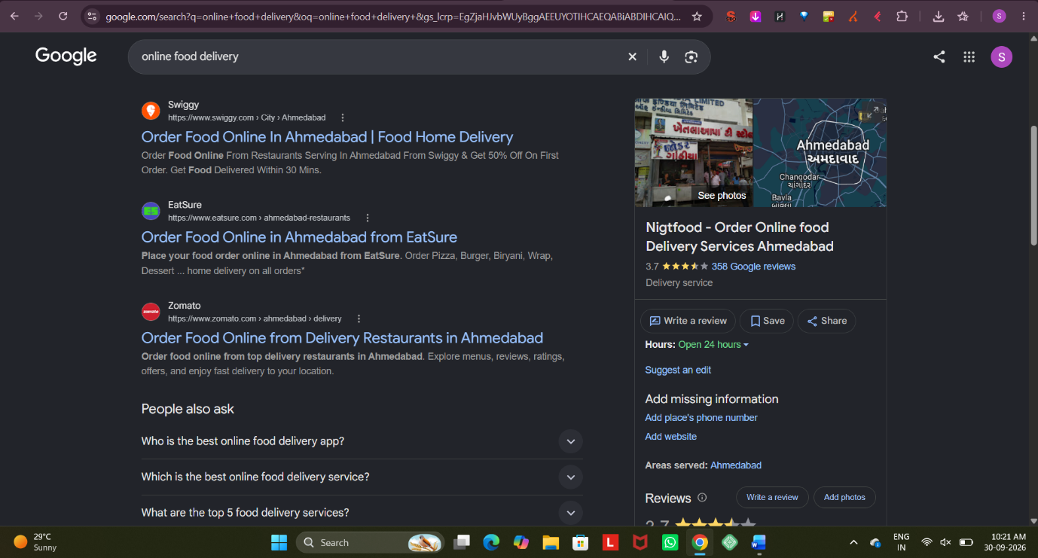
3. Scenario: Flipkart Seller Using PPC for New Smartphone
Product: Seller launches new model "Infinix Hot 60 Pro 5G" on Flipkart.
How he uses PPC:
The seller runs Flipkart Search Ads (PLA) and Google Ads to get instant visibility instead of waiting for organic ranking.
Keywords Targeted:
- Exact match: Infinix Hot 60 Pro 5G, Infinix new phone 2026
- Category keywords: best phone under 15000, 5G phone with best camera, gaming smartphone
- Competitor keywords: Redmi Note 13 alternative, Realme Narzo 70
- Long-tail: best battery phone under 15000 Flipkart
He sets a daily budget of Rs. 2000, bids Rs. 8 per click, links ad to Flipkart product page with offer "Launch Offer - Rs. 1000 off + Free Earbuds".
Expected Outcome:
- Immediate Top Visibility: Ad appears on top when user searches the keywords on Google and Flipkart.
- Increase in Sales & Reviews: 300-400 clicks/day converts to 8-10% sales, getting initial 30-50 orders and first reviews quickly.
- Organic Rank Boost: Early sales velocity improves Flipkart's own organic ranking, so even after stopping ads, product stays higher.
4. PPC for a New Zomato-style Food Delivery App Launch
App Name: Let's say FoodJet - 30 Min Delivery App
3 Advantages:
- Instant Visibility in Competitive Market: For keywords like "food delivery near me" dominated by Zomato/ Swiggy organically, PPC puts FoodJet at the top on Day 1 itself.
- Hyperlocal & Intent-Based Targeting: Can target only by city, pincode, time (e.g., 7pm-11pm), device (mobile), and high-intent keywords like "order biryani online Ahmedabad".
- Measurable ROI & App Installs: Pay only when someone clicks. Can directly track Cost Per App Install, Cost Per First Order and stop non-performing keywords.
2 Disadvantages:
- High Cost & Budget Burn: Food delivery keywords are very expensive (Rs. 20-60 per click). For a new app with low budget, costs can burn fast without guaranteed orders.
- Low Trust & No Long-term Benefit: Users trust organic Zomato/Swiggy more than a new sponsored app. Once you stop paying, traffic stops completely - unlike SEO or word-of-mouth which stays.
5. 5 Catchy Google Ads Headlines for IPL Fantasy League App
Generated for: IPL Cricket Fantasy League App (e.g., Dream11 style)
Here are 5 AI-generated headline suggestions:
- "Your IPL Team, Your Rules - Win Big Daily!"
- "Pick 11, Win Crores - IPL Fantasy Is LIVE!"
- "Think You Know IPL? Prove It & Win!"
- "Play IPL Fantasy - Rs.1 Crore Mega Contest Today"
- "From Couch to Captain - Create Your IPL Dream Team"
My Favorite Pick: Headline No. 2
Reason: "Pick 11, Win Crores - IPL Fantasy Is LIVE!"
It is short (fits Google Ads 30-char limit), has a clear Call-to-Action (Pick 11), high reward appeal (Win Crores), and urgency (LIVE). It perfectly matches high-intent IPL search traffic.

